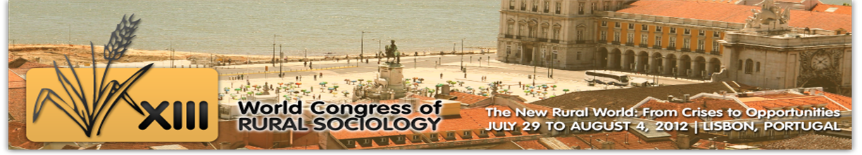

IRSA WORLD CONGRESS SESSION 57
Session number 57: Global crises, contested politics and emerging paradigms in rural Mediterranean

Session organizers :
Alia Gana : UMR LADYSS CNRS, University of Paris, alia_gana@yahoo.fr
Maria Kousis, University of Crete, kousis@social.soc.uoc.gr

Abstract:

Connected by history, geography and neighborhood relations, the Mediterranean constitutes an area of interface as well as of divide between the North and the South. Belonging to this strongly contrasted regional entity, the Mediterranean rural spaces constitute an interesting field for the investigation of the plurality of impacts and responses that current economic, environmental and political crises generate. Given the lack of comparative works on the rural dimension of recent crises in the Mediterranean, the session aims to bring together scholars working on current dynamics of change, involving actors, institutions or/and policies, in the following areas: the agro-food systems rural livelihoods and economies, mobilities, rural/urban relations, conflicts over resources, water and climate change. Of particular interest are the contested politics emerging in these areas and initiatives towards more sustainable (and more North-South cooperation based) rural development models. Encouraged are submissions analyzing these themes in a comparative perspective across the Mediterranean.

Please address any questions about this session to Alia Gana (alia_gana@yahoo.fr) and Maria Kousis (kousis@social.soc.uoc.gr) Please submit a brief abstract (150 words) by 15 January 2012 online (http://irsa2012.com/event/irsa-2012/proposals/). Indicate that you are submitting your paper to Session 57. Only online submissions will be accepted.

